

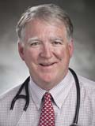

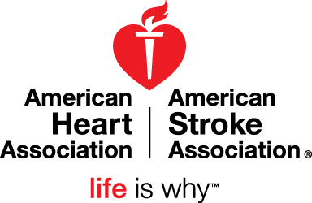

## **A MESSAGE FROM THE AHA**

January 2015

Dear School Coordinator:

Happy New Year! I hope you had a wonderful holiday break, filled with relaxation and time with family and friends.

I am writing to you as the President of the American Heart Association’s Midwest affiliate to **thank you**.

**Thank you** for partnering with the American Heart Association. **Thank you** for the time and energy you put into organizing your school’s event to benefit the AHA, whether it be Jump Rope for Heart, Hoops for Heart, a Red-Out or other activity. **Thank you** for helping your students to lead healthy, active lives and to learn a little about philanthropy and giving back to others. **Thank you** for doing all this on top of your already busy schedule. We appreciate you!! And let me tell you – your efforts truly do make a difference.

This past fall, the latest statistics came out about the leading causes of death in the United States. According to the Centers for Disease Control and Prevention (CDC), death rates for the leading causes of death dropped as follows:

* Heart disease dropped 1.8%
* Cancer dropped 1.5%
* Stroke dropped 2.6%

While that’s all great news, I’ll be honest. I had hoped this would be the year heart disease finally fell off the top spot as the leading cause of death …because we are so close!

Thanks to you and our other partners, we have reduced the number of people dying from heart disease each year. Did you know that over the past 12 years, heart disease death rates have fallen an **amazing 30%**? No other disease has dropped like that. Experts say the reductions can be attributed to:

* fewer people smoking and being exposed to secondhand smoke;
* improvements in emergency care and treatments for heart disease and stroke;
* lifesaving scientific research breakthroughs;
* changes in laws to build healthier environments; and
* increased awareness about healthy living.

The American Heart Association plays a key role in each of those efforts, through building healthy environments, scientific discovery, CPR training, and education. YOU’VE played a key role in helping achieve that unprecedented progress as well!

But we’re not there yet. In addition to being a volunteer for the American Heart Association, I’m a Cardiologist. In my office, I see people everyday living with the effects of heart disease, heart failure and stroke. I see people dealing with risk factors such as obesity, high blood pressure and unhealthy diets. We still have a ways to go. But we can get there, with your help.

**You** are how we do it. And **life** **is why** we do it.

With Gratitude,

cid:image001.jpg@01CEF0F9.118F4CD0

Andrew Rauh, M.D. - President

American Heart Association, Midwest Affiliate