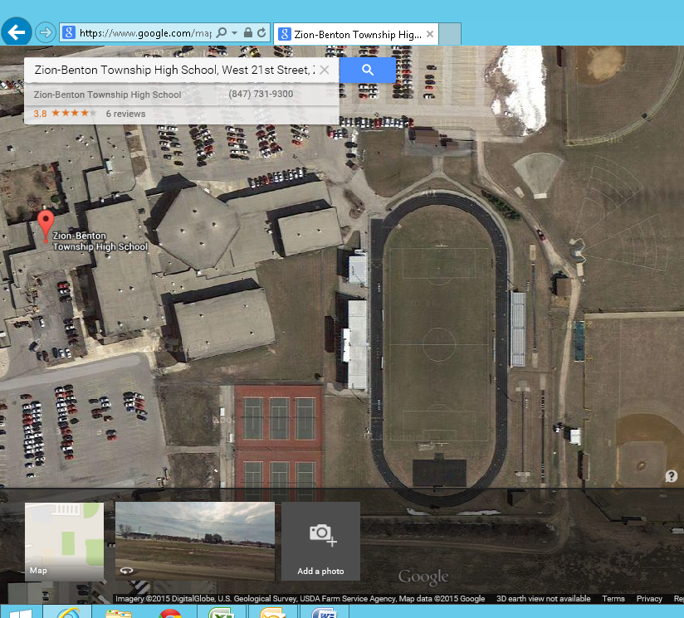
North Entry Gate
Restrooms
Finish Line
Team Tent Areas
Bullpen Area
High Jump
Long Jump
Discus
Shot Put
Concessions
West Entry Gate

* Please keep team camps/tents in the designated areas only. Please make sure your team cleans up after themselves and uses the trash cans provided.
* Bus parking in either the north or south parking lots, being aware not to use up unnecessary parking stalls.
* There is an entry gate on the west and north sides of the track area.

