**Coordinator View for the Jump/Hoops Mobile App!**



**YOU can track the life-saving Ducks your students earn by using the the mobile app for Coordinators! Here’s how to use it…**

Android- Google Play

**Step 1:** Go to the ITunes App store or Android Google Play Store and download the application called ***Jump/Hoops*** or scan the QR Code

iTunes

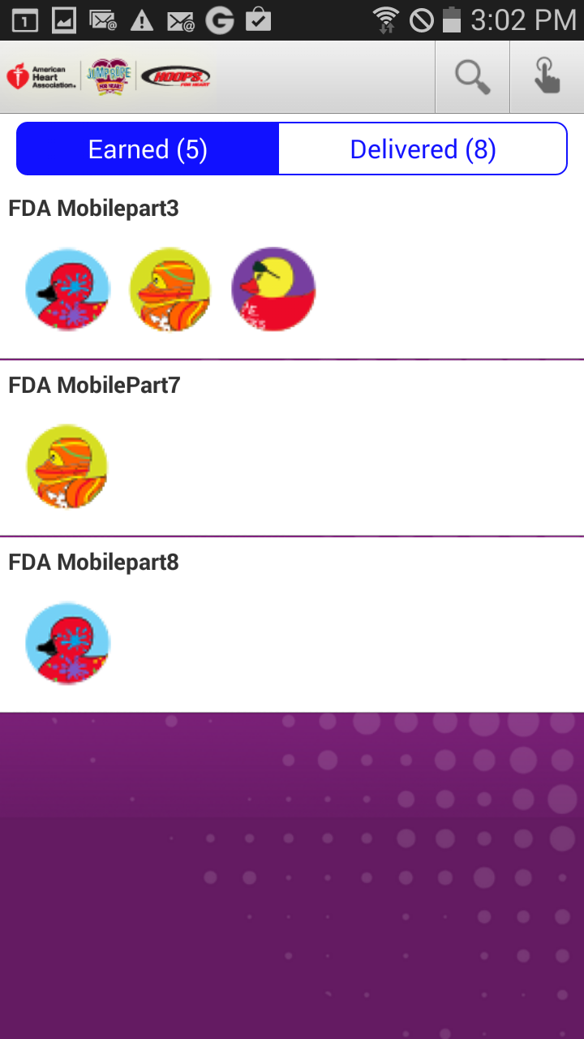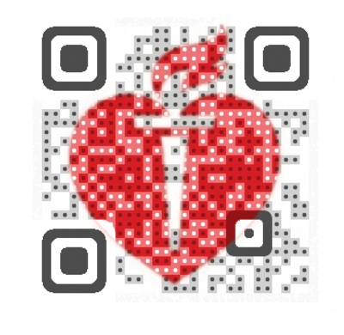

**Step 2:** Once downloaded, open the app and enter your Jump/Hoops username and password (the one you use online) and click LOAD EVENT. The app will take you directly to the Badge Screen.

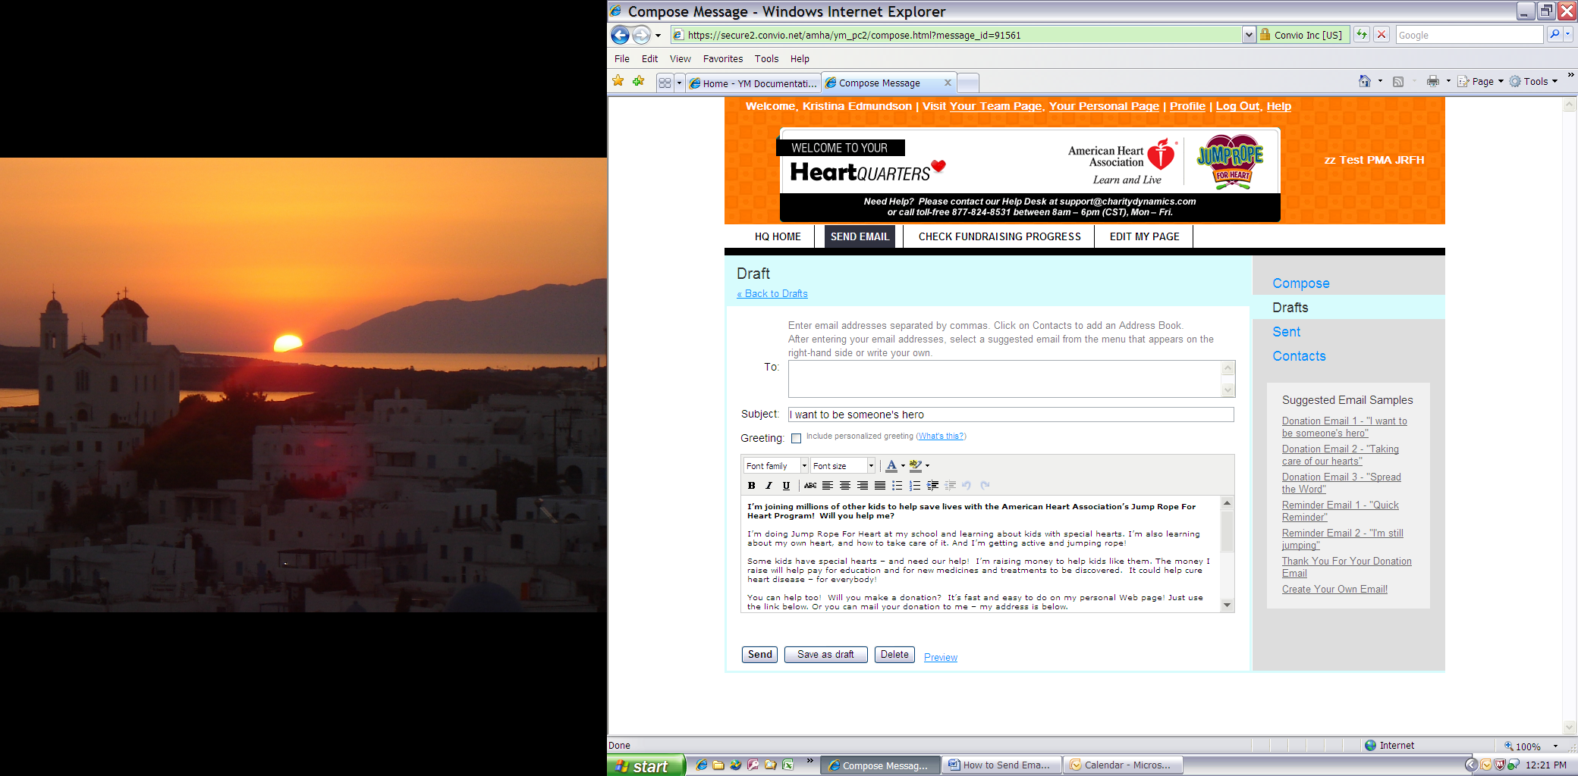

**Step 3:** You will see your Team Page. Simply click on “Awards” in the top right hand corner of the screen where you can track the Life-Saving Ducks that have been earned and distributed.

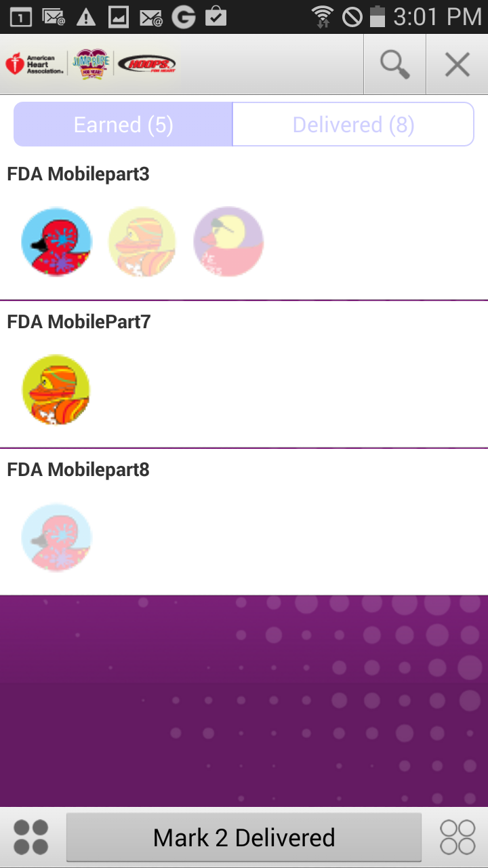

Rewarded ducks will be moved to the “Delivered” Tab

Touch the duck that has been distributed.

**Step 4:** To mark or unmark a Duck as delivered: Press the picture until the duck is highlighted. You can choose as many ducks as you want to mark delivered at one time. Once you have made your selection just click the “Mark Delivered” at the bottom and the screen and the ducks will now be visible on the delivered tab. You can quickly mark ducks “Undelivered” by visiting the delivered tab and going through the same steps.

Move the rewarded ducks to the “Delivered” tab by clicking here.